SET A
QUE 1 : DIRECTORY AND FILE MANAGEMENT
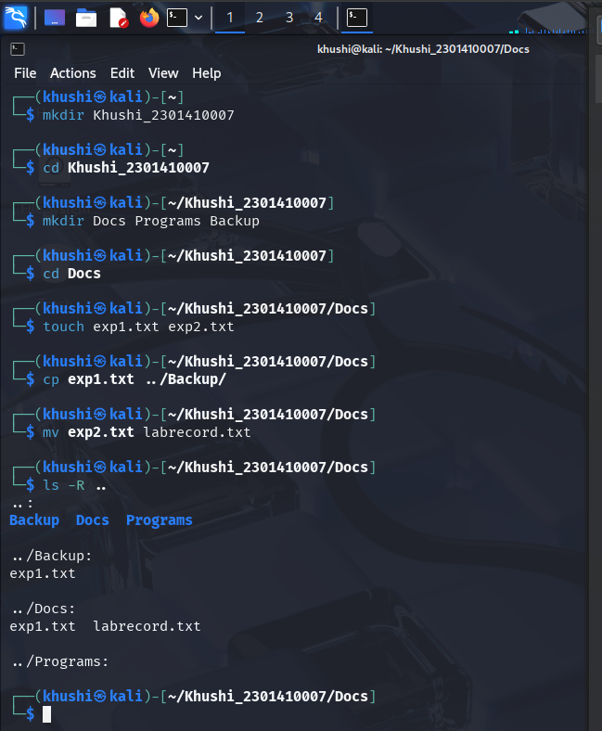

QUE 2: SHELL SCRIPT WRITING
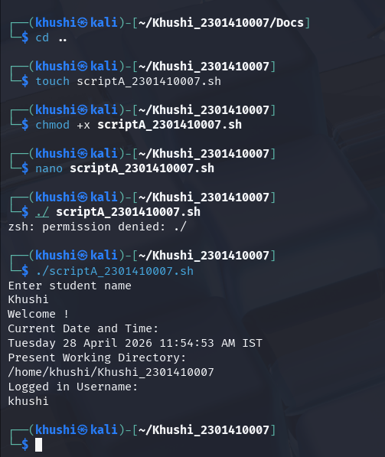
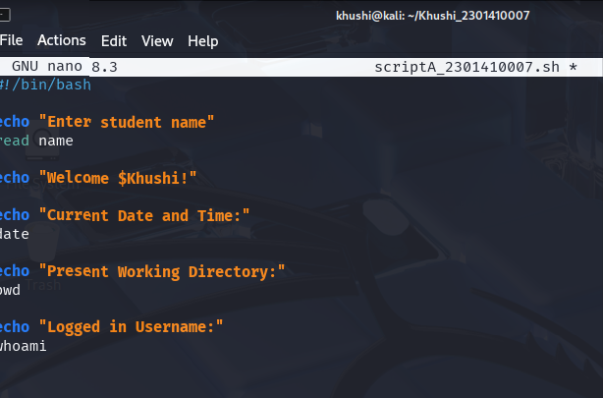

QUE 3: PERMISSIONS AND TEXT COMMANDS
